STAC67 HW1

1. (a)

> GPA=read.table("GPA.txt",header=F)> GPA
V1 V2
1 3.897 21
2 3.885 14
.
.
.
118 3.914 28
119 1.860 16
120 2.948 28
>

> Y=GPA$V1
> X=GPA$V2
> n=length(Y)
> Xbar <- mean(X)
> Ybar <- mean(Y)
> Xbar
[1] 24.725
> Ybar
[1] 3.07405
ssX <- sum(X^2)
> ssX[1] 75739
> ssX <- 0
> for(i in 1:n){
+ ssX <- ssX + X[i]^2
+ }
> ssX

[1] 75739
> spXY <- sum(X * Y)
> spXY[1] 9213.112

> b1 <- (spXY - n * Xbar * Ybar)/(ssX - n * Xbar^2)
> b1[1] 0.03882713
> b0 <- Ybar - b1 * Xbar
> b0[1] 2.114049

Therefore b1=0.03882713 and b0=2.114049; the estimated regression function is
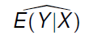= 2.114049+0.03882713X

(b)
> abline(a = b0, b = b1)
> plot(X, Y, xlab = "ACT test score", ylab = "Average GPA at the end of the freshman year")
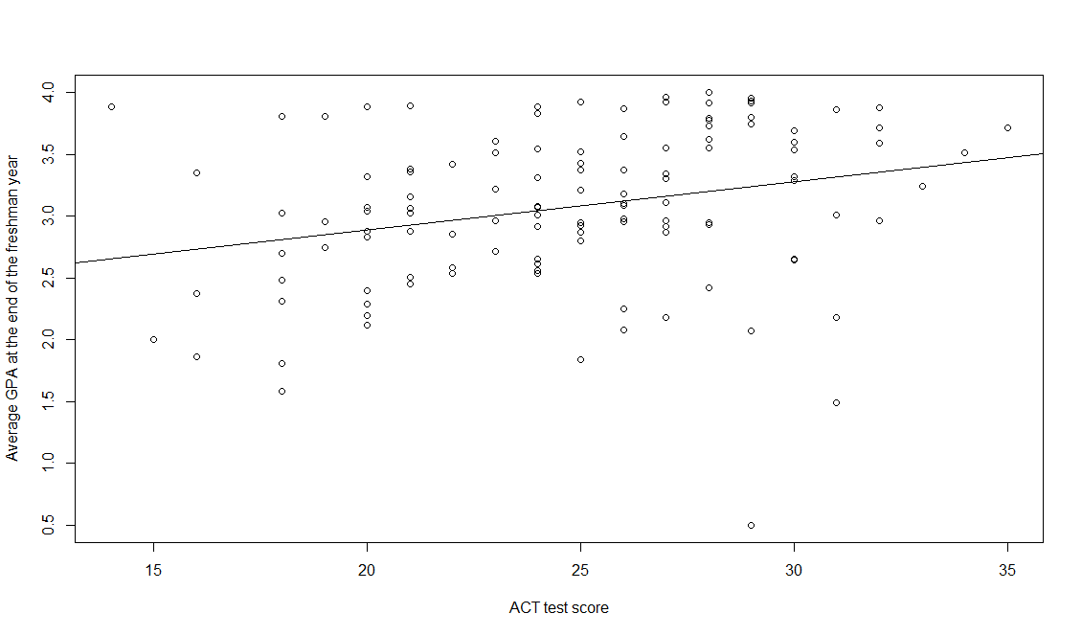
From the data, yes the the estimated regression function to fit the data well.

(c)
(x=30) =2.114049+ 0.03882713*30= 3.2788629

(d) change in the mean = b1= 0.03882713

- (a)
> Yhat <- b0 + b1 * X
e <- Y - Yhat
> e [1] 0.96758105 1.22737094 0.57679116 -0.42824608 0.09858105 0.54730978
[7] -0.39451735 0.79861829 -2.74003597 0.05444541 0.26409967 0.25913691
[13] 0.03709967 -0.03290033 -0.15034448 -0.19938171 0.43727254 -0.30469022
[19] -0.13772746 -0.77259183 -0.48290033 0.42758105 0.52979116 0.76261829
[25] 0.35479116 -0.02255459 -0.78120884 -0.38924608 0.74744541 0.13058105
[31] 0.84227254 -0.36028332 -0.27220884 0.25144541 -0.11124608 0.02609967
[37] 0.45158105 0.01113691 0.38661829 0.52244541 -0.14555459 -0.62486309
[43] -0.50590033 -0.87355459 -1.17103597 -0.42890033 -1.13469022 -0.69645619
[49] 0.10023530 0.99306243 -0.29138171 0.61671668 0.14261829 -0.17155459
[55] 0.50109967 0.41213691 0.23058105 -0.69659183 0.04413691 0.69596403
[61] -0.16272746 -0.29107321 0.28527254 0.59892679 -0.63686309 -0.47741895
[67] -0.39090033 0.35748265 -1.00693757 0.50892679 0.14840817 -0.04107321
[73] -0.33093757 -0.11293757 0.67996403 -0.05659183 0.21492679 -0.03955459
[79] 0.79879116 0.07682840 0.43240817 0.18140817 -1.04455459 0.51848265
[85] 0.12327254 -0.24238171 0.18261829 0.71596403 0.95623530 -0.42341895
[91] 0.84009967 -0.97938171 0.34427254 0.21106243 0.50996403 0.78709967
[97] -0.04938171 -0.05441895 -0.10476470 -0.50193757 -1.24372746 -1.22993757
[103] -0.01159183 0.23448265 -0.13190033 0.24300127 -0.28472746 0.41979116
[109] 0.59079116 -0.21772746 0.45075392 0.32113691 -0.49659183 -0.60459183
[115] -1.83169022 0.99440817 0.55996403 0.71279116 -0.87528332 -0.25320884
> Sum=sum(e)
> Sum
[1] 1.065814e-14

Yes, from the code,it sums to zero.

(b)
> SSE = sum(e^2)
> MSE = SSE/(n - 2)
> MSE[1] 0.3882848
> s = sqrt(MSE)
> s[1] 0.623125

Therefore σ^2=MSE=0.3882848 and σ=0.623125; σ is positive.

3. Please see the written sheet.

4. Please see the written sheet.

5. (continued from 2(b))
> s2b1 <- MSE/(ssX - n * Xbar^2)
> sb1 <- sqrt(s2b1)
> t <- b1/sb1
> ttab <- qt((1 - 0.01/2), n - 2)
> pvalue <- 2*(1- pt(t, n-2))
> c(b1 - ttab *sb1, b1 + ttab *sb1)
[1] 0.005385614 0.072268640

Therefore the 99% confidence interval is (0.005385614, 0.072268640)
Based on our sample data, if we draw a large amount samples of size 120, almost 99% of such samples will provide b1 between 0.005385614 and 0.082268640. It does not include zero. The director might be interested in whether the interval contains zero because it determines whether the model is significant and whether they can predict the mean freshman GPA. If the interval contains zero, then the null hypothesis that beta1=0 is true, which implies the regression model is insignificant, that x cannot explain y. I.e the ACT test score has no significant explanation power hence they cannot predict the mean freshman GPA.
- (a)
> Yhhat_28=b0+b1*28
> Yhhat_28
[1] 3.201209
> s2Yhhat=MSE*((1/n)+((28-Xbar)^2/(ssX-n*Xbar^2))
> s2yhhat
[1] 0.004985593
> syhhat=sqrt(s2yhhat)
> syhhat
[1] 0.07060873
> tsta=qt((1-0.05/2), n-2)
> c(yhhat_28-tsta*syhhat, yhhat_28+tsta*syhhat)
[1] 3.061384 3.341033

Therefore, the 95% confidence interval is (3.061384, 3.341033); this means the mean freshman for students with ACT test score equal to 28 will be approximately between 3.061384 and 3.341033 with 95% probability.

(b)
> s2spred=MSE+s2yhhat
> sspred=sqrt(s2spred)
> sspred
[1] 0.6271128
> c(Yhhat_28-tsta*sspred, Yhhat_28+tsta*sspred)
[1] 1.959355 4.443063

Therefore, the 95% confidence interval is (1.959355, 4.443063); this means Mary’s GPA will be approximately between 1.959355 and 4.443063 with 95% probability.

(c)
Yes, the prediction interval in part b is wider than the confidence interval in part a; yes it should be.

(d)

7. (a)
> reg = lm(Y~X)
> anova(reg)
Analysis of Variance Table

Response: Y
Df Sum Sq Mean Sq F value Pr(>F)
X 1 3.588 3.5878 9.2402 0.002917 **
Residuals 118 45.818 0.3883
---
Signif. codes: 0 ‘***’ 0.001 ‘**’ 0.01 ‘*’ 0.05 ‘.’ 0.1 ‘ ’ 1

(b)
MSR estimates 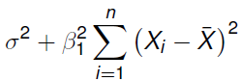, MSE estimates 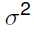; MSR and MSE will estimate the same quantity if 1=0.

(c)
H₀: 1=0
H_{A}: 1≠0
> FTAB <- qf(0.99,1,118)
> FTAB
[1] 6.854641

Therefore f(0.99,1,118)= 6.854641.
Decision rule： when is 0.01,
if F>6.854641, we reject the null hypothesis;
If F<6.854641, we accept the null hypothesis.

Since F=9.2402>6,854641, we reject the null hypothesis; therefore the model is significant.

(d)
The absolute magnitude of the reduction is SSR, 3.588; the relative reduction is SSR/SST= 3.588/(3.588+45.818)=7.262276%. The name of the latter measure is 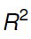, the coefficient of determination.

(e)
The correlation coefficient r=+sqr(7.262276%)= +0.269486

(f)
r only gives linear association between x and y and shows the amount of variability in the response variable that is explained by the fitted linear regression model. Therefore has the more clear-cut operational interpretation.

